2019 RUSSIAN OPEN DANCESPORT CHAMPIONSHIPS
2019 WDSF WORLD CHAMPIONSHIP TEN DANCE

INVITATION
One couple per WDSF National Member Body is cordially invited:

DATE: | 26 October (Saturday)
Competition venue:  Gymnastics Palace of Irina Viner-Usmanova  Address: Moscow, Luzhniki street, 24/24  Russian Federation | 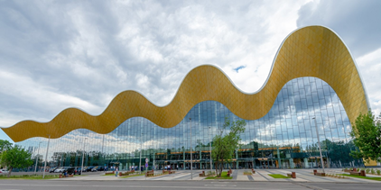
Hotel accommodation for couples:  KORSTON HOTEL  A double room for two nights  with breakfast, October 25-27 | 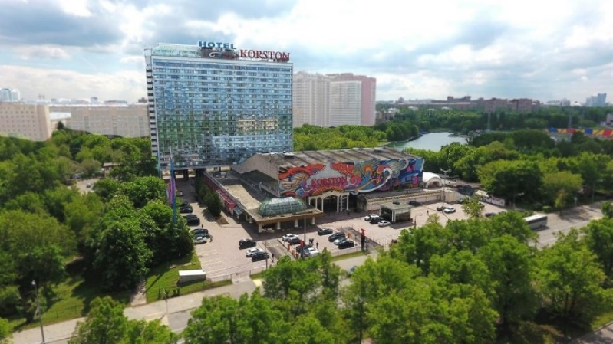  Contact person: Ekaterina Stefankina  FDSARR Office, dancesport@rosfarr.ru
Hotel accommodation for coaches: | Elizaveta Bobkova, e.bobkova@acase.ru
Visa support: | FDSARR Office: dancesport@rosfarr.ru
Transfer airport-hotel-airport | Provided by the Organizer
Closest airport | Sheremetyevo Airport
Shuttle buses | From the hotel to the venue and back
Accreditation for coaches | One coach per couple
Opening ceremony and parade | Mandatory for all participants
Entries | To be submitted by WDSF National Member Bodies to the FDSARR Office by email: dancesport@rosfarr.ru  Expiry date: September 30, 2019
Other events | 2019 Russian Open DanceSport Championships  October 21-27  WDSF GrandSlam Latin (October 25-26)  WDSF GrandSlam Standard (October 26-27)  On-line registration https://fdsarr.ru/dance/
ORGANIZER | ALL RUSSIAN FEDERATION OF DANCESPORT AND ACROBATIC ROCK’N’ROLL (FDSARR)  Tel: +7 495 787 27 70  E-mail: dancesport@rosafrr.ru  www.fdsarr.ru

2019 WDSF WORLD CHAMPIONSHIP TEN DANCE
October 26, 2019
Moscow, Russian Federation

PLEASE FILL IN AND SUBMIT TO THE ORGANIZING COMMITTEE
E-MAIL: DANCESPORT@ROSFARR.RU

ENTRY FORM

WDSF NATIONAL MEMBER BODY
COUNTRY

PARTICIPANTS
MALE PARTNER |  | FEMALE PARTNER
NAME |  | NAME
SURNAME |  | SURNAME
MIN |  | MIN
DATE OF BIRTH |  | DATE OF BIRTH

NOMINATED COACH
NAME

HOTEL ACCOMMODATION FOR THE COUPLE
Korston Club Hotel Moscow
CHECK-IN time 14.00 |  | CHECK-OUT time 12.00
DATE |  | DATE

TRAVEL DETAILS
ARRIVAL |  | DEPARTURE
DATE |  | DATE
AIRPORT |  | AIRPORT
FLIGHT NUMBER |  | FLIGHT NUMBER
TIME OF ARRIVAL |  | TIME OF DEPARTURE

